**Exercise 4**

1. Try to ping common websites like google, Bennett University etc. from VMs created before. Does it succeed? Why / Why not?

Yes all pinging activities succeed if the server is up on the public web (WAN in a sense). Pinging outside LAN doesn’t succeed via metasploitable. The reason maybe that the network adapter is set to be host only. Or the reason is a lack of a network setup.

1. Identify the output for route commands and ifconfig (ipconfig on windows) on all three machines (Host, Kali-VM and Metasploitable-VM ) Observations and Notes:

My Kali-VM has two interfaces, eth0 and lo. One is the ether interface and the other is the loopback. The ether has a MAC address 00:0c:29:72:e9:a4 with an inet of 192.168.92.138. The lo interface has a inet of 127.0.0.1

The metasploitable VM also has lo and eth0. However the HWaddr is 00:0c:29:4b:fb:bd and the inet is 192.168.117.128 instead. My host’s IP is 192.168.0.111 and the gateway address is 192.168.0.1. VMWare’s network adapters are connected to my host via 192.168.117.1 and 192.168.92.1 granting the IP addresses to my virtual machines.

1. Do ssh / rlogin / telnet to remotely connect to Metasploitable-VM from Kali-VM. Once successful, look at output of “netstat -a -p -n” command. Observations and Notes:

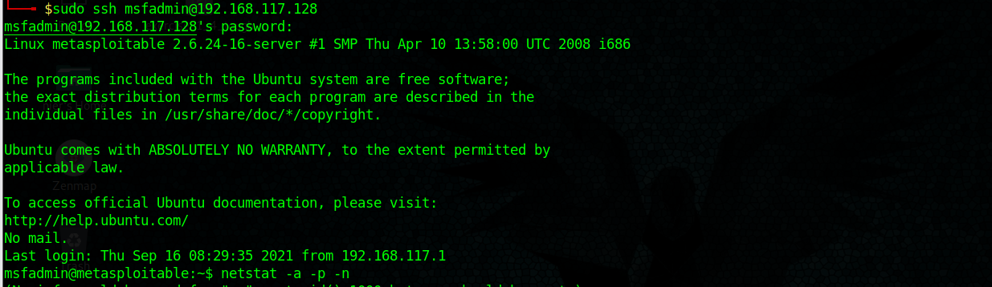

SSH connection is made with the msfadmin user easily

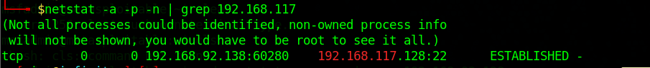

Netstat shows a TCP connection from my Kali VM to the metasploitable VM on port 22

1. How does SSH differ from Telnet (to be fully answered after Wireshark module)?

In my understanding, Telnet is very much less secure than SSH and it is often not used for remote connections as its terribly insecure.